Nutrition: Food Record Instructions
Instructions
- Choose three typical days and record everything you eat and drink. Days do not have to be consecutive. Be sure to include one weekend day.
- Print clearly using black or blue ink.
- Record each meal or snack immediately after it is eaten.
- In the first column of the food record, use ‘H’ for meals eaten at home, and ‘A’ for meals eaten away from home.
- When eating out, include the name of the restaurant or food vendor.
- Include brand names wherever possible.
- Include condiments and any other “at the table” additions.
- Include all ingredients for combination foods such as pizza, sandwiches, casseroles, omelets, salads, etc.
- Use the most convenient method to record portions such as number, size, weight, or volume.
- Include food preparation method, such as breaded, fried, baked, boiled, sautéed, etc.
- Leave 3 or 4 blank lines between meals.
- Start each new day on a new page.

Tips for Measuring Portions
The following pointers will help you give more accurate measurements and descriptions of the foods and beverages that you eat and drink.

The “Rule of Hand”
 | A thumb is… | 1 tablespoon, 15 ml or 15 g
 | A thumb tip is… | 1 teaspoon or 5 ml
 | A palm is… | 1 serving of meat, fish, poultry, 50-100 g, 2-3 oz.
 | A fist is… | 1 cup or 250 ml

Recording Measurements
Measurement | Type of food
Fluid ounces (fl. oz.) | Beverages – all types, including alcoholic | 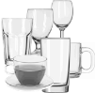
Number and size  (sm., med., lg.) | Bread, rolls, crackers  Raw fruits and vegetables  Cookies, snack items, candy, etc. | 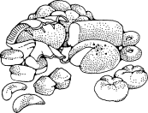
Weight in ounces (oz.),  specify cooked or raw weight | Meat, poultry, fish, shellfish, cheese  If weight is unknown, record dimensions:  (length x width x thickness) | 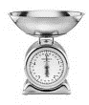
Serving (sv.) and size | Pie, cake (ex. Cherry pie 1/16 of an 8” pie) | 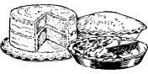
Cups (c.) | Potatoes, rice, cereals, soups, casseroles  Fruits, vegetables (cooked or canned) | 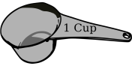
Teaspoons (tsp.) or  Tablespoons (Tbsp.)  Note: 3 teaspoons = 1 tablespoon | Jelly, jam, sugar, syrup, sauces, gravies,  Salad dressing, butter, margarine, nuts, seeds | 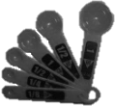

Portions the size of…
A deck of cards | is the same as… | 3 ounces cooked meat, poultry or fish | 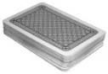
A large egg | is the same as… | 1 average muffin
A golf ball | is the same as… | 2 tbsp. peanut butter
A computer mouse | is the same as… | A small baked potato
A 4-inch CD | is the same as… | A pancake or waffle
A baseball | is the same as… | 1 medium apple or orange
Four (4) casino chips | is the same as… | 4 small cookies (like wafers)
Six (6) dice | is the same as… | 1 ½ ounces of cheese | 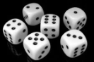

Food Intake Record – Day 1
Date: |  |  | Day of the Week: Sun Mon Tue Wed Thu Fri Sat
H (home)  A (away) | Time of day | FOOD AND BEVERAGES  Be as specific as possible |  |  | Amount | Cooking Method | Fat Used  In Cooking
Vitamins: Yes No |  |  |  | If yes, TYPE and DOSE:

Food Intake Record – Day 2
Date: |  |  | Day of the Week: Sun Mon Tue Wed Thu Fri Sat
H (home)  A (away) | Time of day | FOOD AND BEVERAGES  Be as specific as possible |  |  | Amount | Cooking Method | Fat Used  In Cooking
Vitamins: Yes No |  |  |  | If yes, TYPE and DOSE:

Food Intake Record – Day 3
Date: |  |  | Day of the Week: Sun Mon Tue Wed Thu Fri Sat
H (home)  A (away) | Time of day | FOOD AND BEVERAGES  Be as specific as possible |  |  | Amount | Cooking Method | Fat Used  In Cooking
Vitamins: Yes No |  |  |  | If yes, TYPE and DOSE:

